Information Södertälje Thursday 3/September 2026

Tips for accommodation around Södertälje:
• Quality Hotel Park Södertälje City – approx. 1688 sek/night 3.8 km to competition area
• Scandic Södertälje – approx. 1616 sek/night 5.9 km to competition area
• Best Western Plus Skogshöjd – approx. 1217 sek/night incl. breakfast 3.4 km to competition area
• The Dock – approx. 1702 sek/night 3.8 km to competition area

Parking for cars and caravans/Motorhomes:
• Parking for cars and guests see map
• Parking for Motorhomes, caravans 2/9 – 3/9 (1 day)
We will be able to offer limited space for this from Wednesday EM 17:00 to Thursday EM at 17:00. (It is advisable not to arrive after 10:00 PM on Wednesday)
We will have room for up to a maximum of 8 teams and before payment we ask that you email us and wait for confirmation.
The cost for this day is 350 SEK and is paid to the club before 27/August to BG: 709-7264 alternative swisch: 123 1335843
Mark the payment with: First & Last name and the car's registration number, 3/9-26
Mail: utstallning@sshk.se – MARK the headline with; P-Husbil/Husvagn
Address to the exhibition area:
Södertälje Brukshundsklubb
151 24 Södertälje
Directions:
From the north - Stockholm:
Continue on the motorway towards Gothenburg, take the exit at Södertälje V - traffic stop Vasa. Drive past Scaniarinken (on the right). Drive straight towards the center in the roundabout. At the next roundabout, turn left (signposted Brukshundklubb). Then second left (sign Brukshundklubb), right next to a school/kindergarten. Drive slowly - respect the speed 30 km through the villa area and out into the forest about 1.5 km.
From the south - Nyköping, Norrköping: Same as above.
From the west - Strängnäs:
Take the first exit at Södertälje V. Then follow the description above.

NOTE!
During the competition day, traffic will be heavy through Södertälje both from the North & South in the morning.
Also be aware that traffic through Stockholm can be just as slow so plan your route with plenty of time to avoid stress.

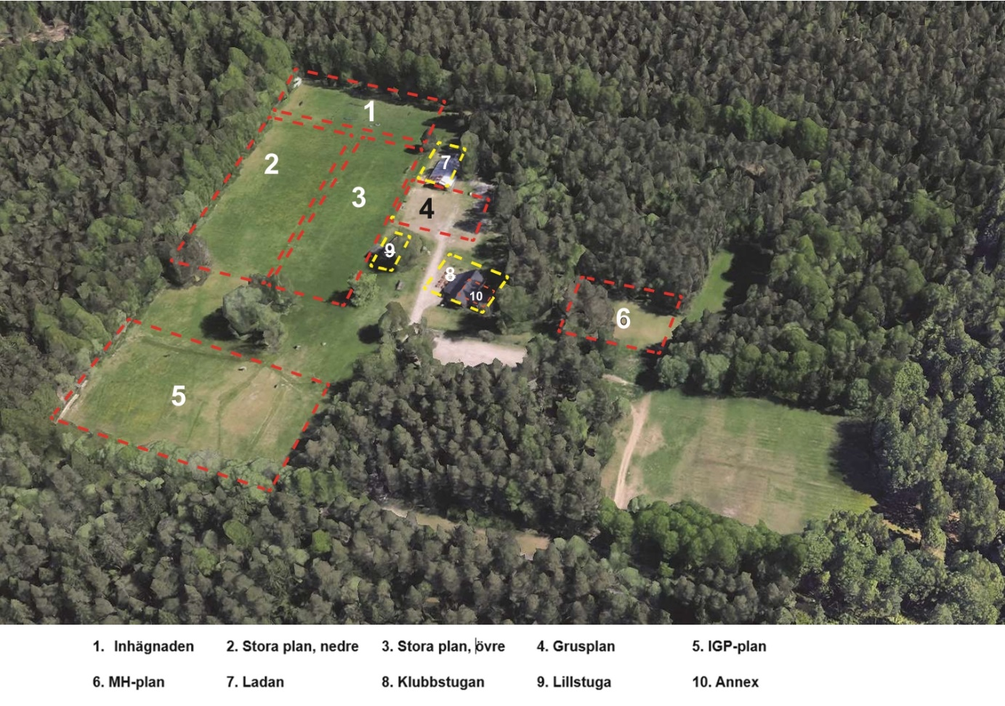
Level 2 & 3 Exhibition rings with space all around for tents, cages and chairs. BUT tent-free between the rings
Level 4 Officials' parking
Level 8 Clubhouse, will be served a simple breakfast and lunch as well as a café with homemade cakes. Here it is also possible to buy lottery tickets and win great prizes
Yellow Star Parking for cars
White Star Parking for campers/caravans
Other levels must not be entered
Café A simple breakfast will be served from 8:00 am as well as some homemade cakes, snacks and between 12-2 pm there is lunch to buy, on this day hamburgers will be served with the possibility of a vegetarian alternative
Lottery There will be lottery tickets to buy during the day with great prizes
Payment The club mainly wishes payment via Swich but for foreign visitors there will be the possibility of paying with Euro.
Photographers We hope that we will have a fantastic day with happy dogs and exhibitors, so much so that we want to capture as many moments on picture as we can, therefore there will be photographer(s) on site during the day. If you do not want to appear in the picture please email us and let us know and we will make sure that your wish is fulfilled.

New for this show is that gifts will not be awarded in the rings, but you will be able to take a card if you got a placement with the respective placement color and choose at the prize tables.
In this way we try to ensure that everyone wins something that suits you.
However, the prizes will be awarded at the respective BIS finals

Products / prizes with a Best Before date will be donated to the dog stable in Stockholm after the competition.

Best Regards SSHK

